Students Level ALL

IQ Recycling & Environmental Stewardship Resource Pack
Collection of favorite videos, activities, puzzles, and lesson plans from the Alabama Public Television/PBS Libraries
https://aptv.pbslearningmedia.org/shared/1590410/4531337/

Recycling Field Day
http://www.educationworld.com/a_lesson/03/lp308-02.shtml
Best Sustainable Practice Lessons
http://www.educationworld.com/a_lesson/Five-Lessons-Teach-Students-to-Reduce-Reuse-Recycle.shtml
Waste Where Does It Come From? Where Does It Go? –Exploration of what humans throw away to go to the fill. Students will consider the dangers of excessive waste and benefits of recycling with optional fieldtrip components.
http://www.dep.state.pa.us/dep/deputate/enved/Rec_Lessons/waste.htm
How Recycling Works Video
https://vimeo.com/51933771
The 3 R’s
https://jr.brainpop.com/science/conservation/reducereuserecycle/

Students Level Elementary
Earth Friendly Entrepreneurs—Class Sustainable Business Project
http://www.educationworld.com/a_curr/curr003.shtml
Web-based Recycling Learning Games
https://www3.epa.gov/recyclecity/activity.htm
Web-based Steel Recycling Game
http://www.recycleroom.org/
Timeless Trash & the Landfill Longevity---Mini Research & Graphing
http://www.educationworld.com/a_lesson/03/lp308-04.shtml
What is a Landfill Lesson Plan & Activities?
http://www.in.gov/idem/iee/2368.htm
Variety of Links to Active Learning Games -- LOVE the Don’t Get Wasted Game
http://www.recycleguys.org/lessonplans.html
Discovering the 3 R’s (upper elementary)
http://www.kidzone.ws/plans/view.asp?i=150
Recycling Mapping Activity
https://jr.brainpop.com/science/conservation/reducereuserecycle/
Recycling Lessons Found in Children’s Classics—clever use of stories like The Three Little Pigs to demonstrate the importance of recycling
http://sciencenetlinks.com/lessons/materials-2-recycled-materials/

Elementary Classroom Reading Books List
Charlie & Lola: We are Extremely Good Recyclers by Lauren Child | 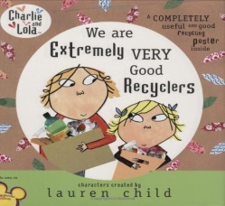
Don’t Throw That Away (younger elementary) by Lara Bergen | 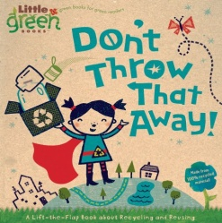
Michael Recycle by Ellie Bethel & Alexandra Colombo | 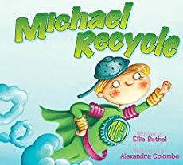
One Plastic Bag: Isatou Ceesay and the Women of Gambia by Miranda Paul | 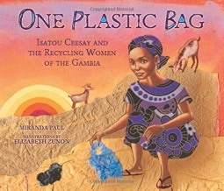
Sofia’s Dream by Land Wilson | 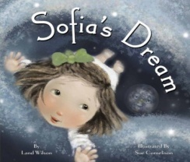
The Adventures of an Aluminum Can by Alison Inches | 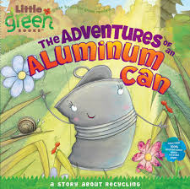
The Adventures of a Plastic Bottle: A Story About Recycling by Alison Inches | 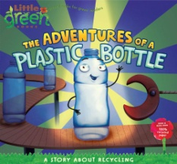
Why Should I Recycle by Jen Green & Mike Gordon | 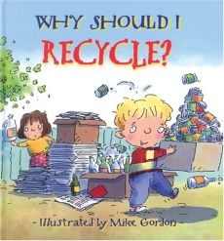

Students Level Middle
Environmental Solutions Webquest
https://educators.brainpop.com/lesson-plan/environmental-solutions-lesson-plan-webquest/?bp-topic=recycling

The Science of Recycling
http://www.discoveryeducation.com/teachers/free-lesson-plans/recycling.cfm

Variety of Links to Active Learning Games -- LOVE the Don’t Get Wasted Game
http://www.recycleguys.org/lessonplans.html
Web-base recycling Scavenger Hunt
http://www.educationworld.com/a_lesson/Internet-Scavenger-Hunt-World-of-Recycle.shtml
Sustainability Conscious Consumers
http://www.educationworld.com/a_lesson/sustainable-products-environmental-responsibility.shtml
Timeless Trash & the Landfill Longevity-Mini Research & Graphing
http://www.educationworld.com/a_lesson/03/lp308-04.shtml
Recycling in Perspective Student create 10 question surveys and conduct interviews (easy -family members or more advanced-1 family member and 2-3 members of the community) to determine community attitudes about recycling— Compile student findings and chart results.
http://www.dep.state.pa.us/dep/deputate/enved/Rec_Lessons/survey.htm
Discovering the 3 R’s
http://www.kidzone.ws/plans/view.asp?i=150
Recycled Art Lesson (grades 3-8)
https://www.teachervision.com/recycling/recycled-art
Recycling Experience Journals
https://www.grownyc.org/files/rcp/Choose_to_Reduce.pdf

Students Level High
Recycling in Perspective Student create 10 question surveys and conduct interviews (easy -family members or more advanced-1 family member and 2-3 members of the community) to determine community attitudes about recycling— Compile student findings and chart results.
http://www.dep.state.pa.us/dep/deputate/enved/Rec_Lessons/survey.htm

